SCREEN1 : When the application starts up the user wil be presented with the following two options.

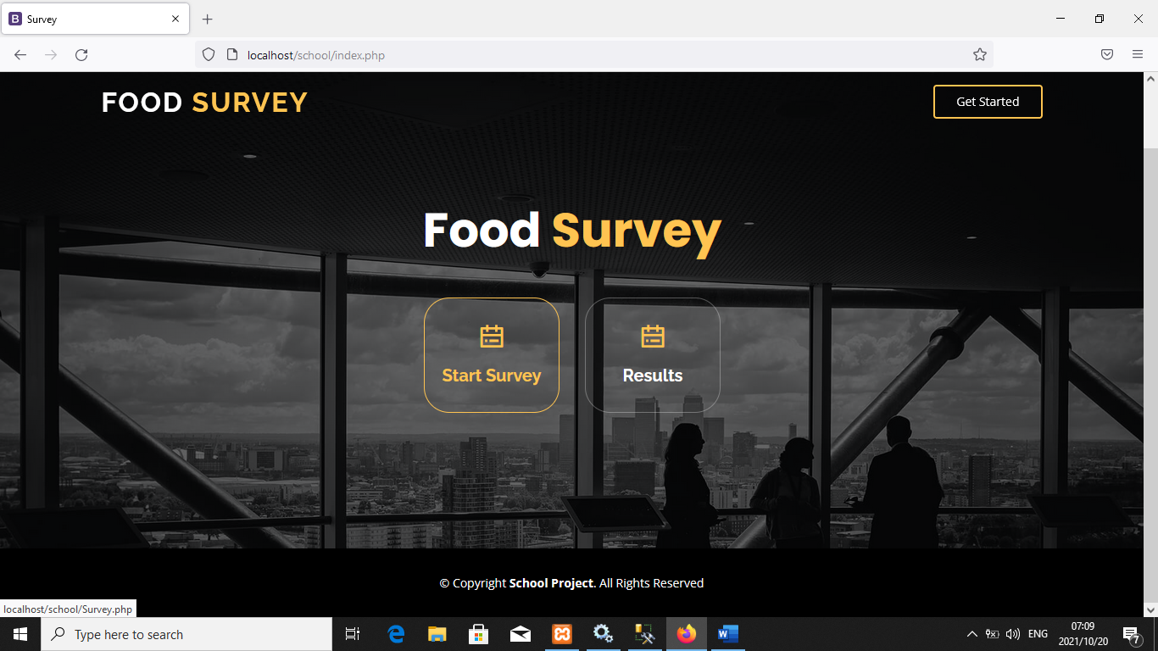

SCREEN 2 : Clicking on the first button will take the user to screen 2

Where the users enter their personal details and select their favourite food together with the scale of 1-5 indicate whether you strongly agree to strongly disagree.

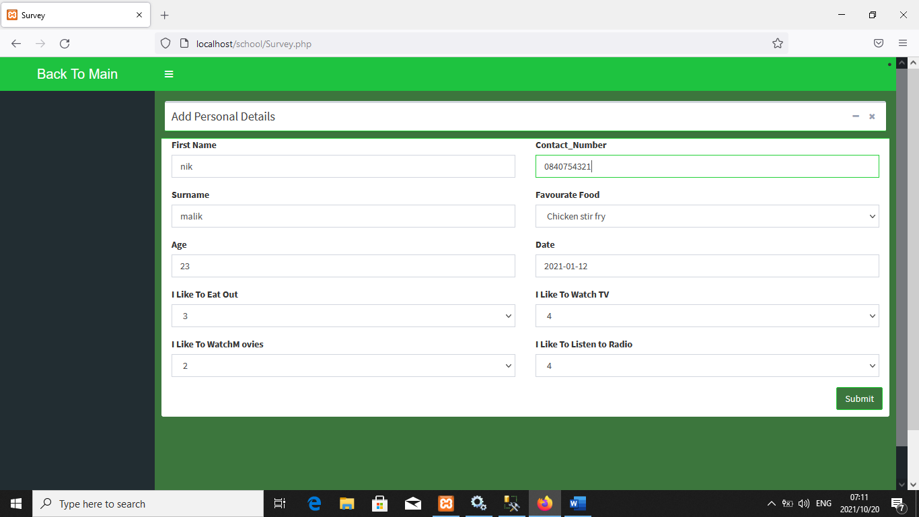

RESULTS SCREEN

SCREEN 3 : When the user click view survey results button then the results screen must show as below.

